Harness Infrastructure and General Troubleshooting
MDFs (Machine Definition File)
- Contains:
  - CAN Port assignments
  - CAT network manager settings
  - Dimensions
- Can present a harness issue since devices will show as not connected with the incorrect MDF selected
- ALWAYS confirm you’ve selected the correct model before digging into harness
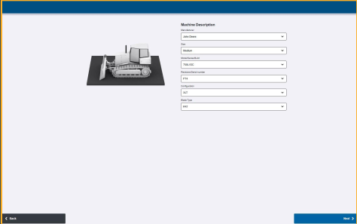
Wiring Issues
Wiring issues are one of the most common support problems. The most common issues are with power, Ethernet, and CAN
Harnessing: Descriptions
All harnessing has descriptive labels on harnessing. This makes it easier to reference diagrams.
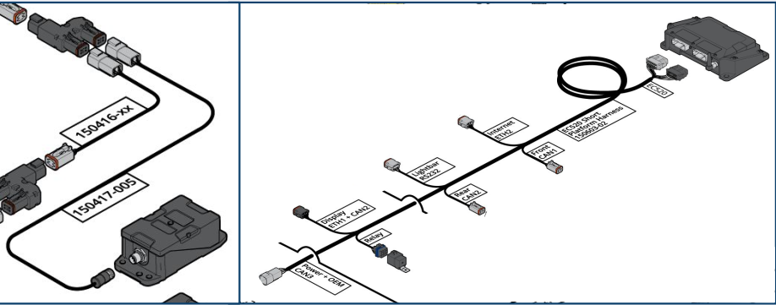
Harnessing: Infrastructure
Seven Communication Paths
Different machines (MDF specific) have different CAN architecture depending on what machine Earthworks is installed on.
- CAN1
- CAN2
- CAN3
- CAN4 / CMR CAN
- ETH1
- ETH2
- SERIAL
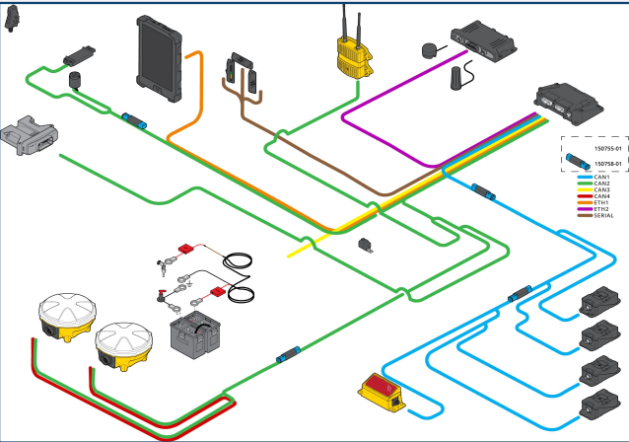
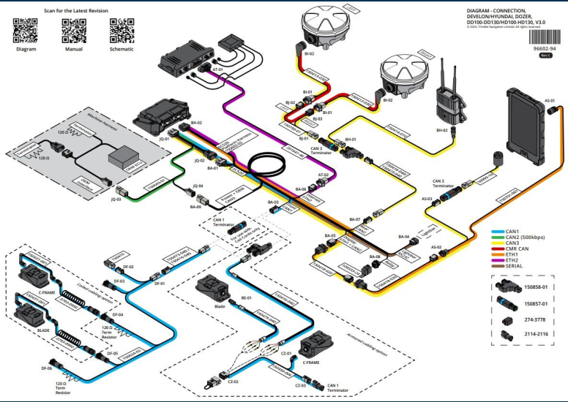
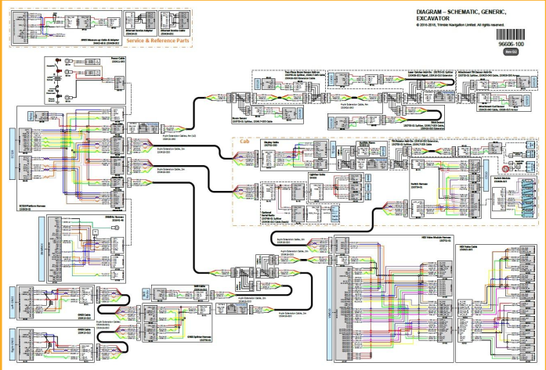
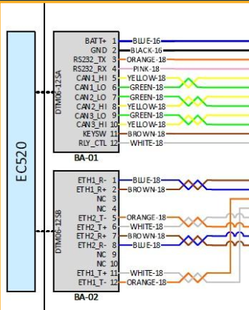
Harnessing: CAN 1
- Typically this bus is used to communicate with the Sensors installed on machine.
- Note the Termination positions. Termination must be installed as per the diagrams to avoid instability issues
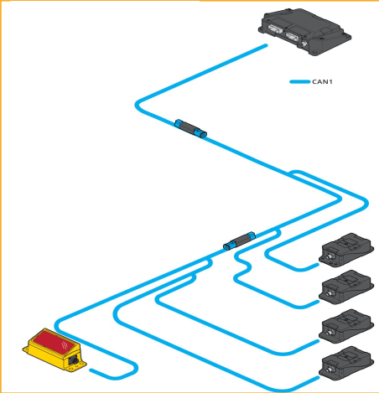
Harnessing: CAN 2
This CAN bus is typically used to communicate with the Valve Module, Radio, and Receivers
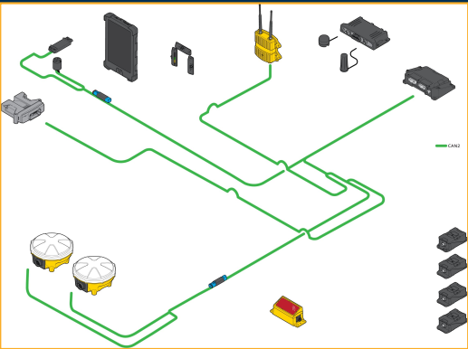
Harnessing: CAN 3-Host Machine
On EH capable machines, CAN 3 is often used for this connection. This connection will allow Earthworks to communicate with the machine’s implement ECM.
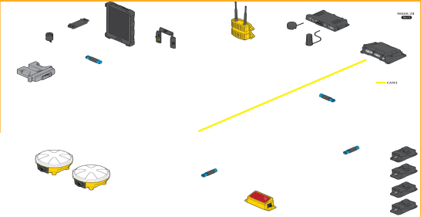
Harnessing: CMR CAN
- GNSS Data Path
- Dedicated Communication
- Built In termination, don’t repurpose
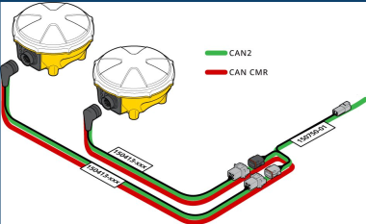
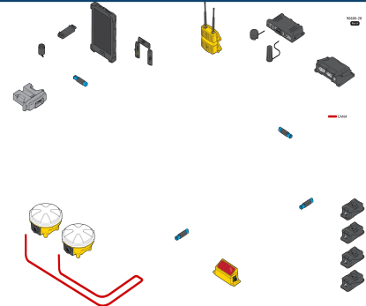
Harnessing: Ethernet 1
Dedicated Communication with TD and EC520
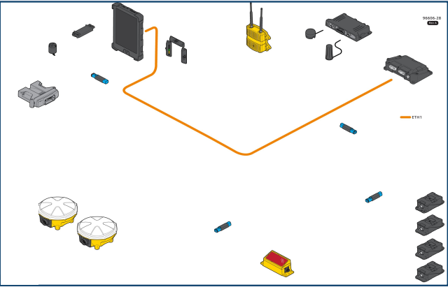
Harnessing: Ethernet 2
Dedicated Communication to SNM94x and EC520
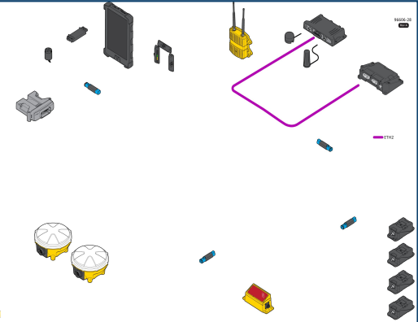
Harnessing: Serial
- LB400 Communication
- Brown Line
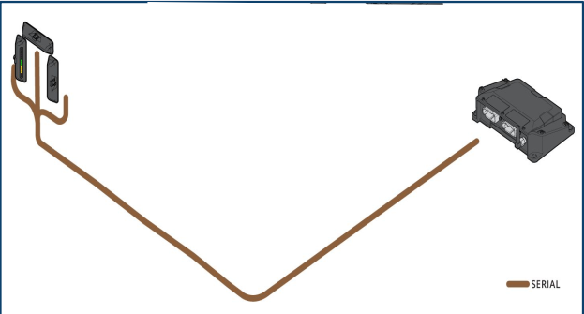
No Power
- If devices are missing check power first
  - Web Interface shows connection status for each component
- Always check which devices have power (EC520/GS5xx no LED’s)
- PM4xx (Power Module) not used in Earthworks, 24V relay is used for power
- Example (Dozer power control)
  - EC520 has machine and key switch power
  - GS5x0 sensor have key switch power
  - Everything else is powered by relay when EC520 detects keyswitch
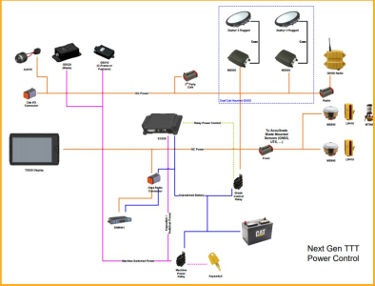
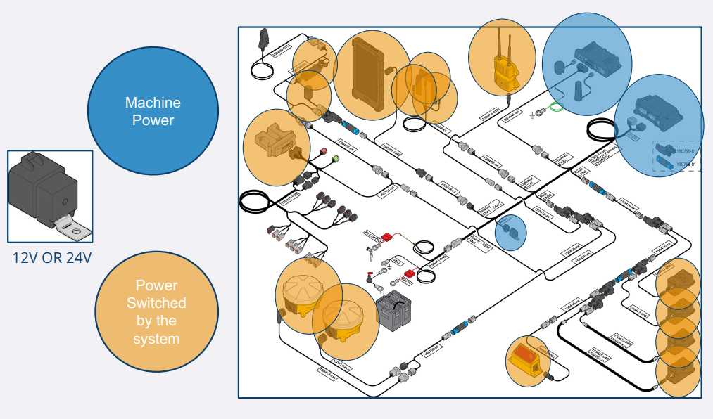
Standard Connectors
Note: The first 6 pins are the same for 6 pin and 10 pin connectors
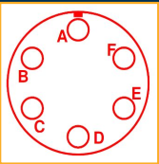
6 Pin Connectors (Sensors)
- A - SW PWR 1
- B - Instance 1
- C - CAN 0 Hi
- D - CAN 0 Lo
- E - Instance 2
- F – GND
10 Pin Connectors (Quicks)
- A - SW PWR 1
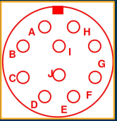
- B - Instance 1
- C - CAN 0 Hi
- D - CAN 0 Lo
- E - Instance 2
- F – GND 1
- G - GND 2
- H - SW PWR 2
- I - CAN 1 Hi
- J - CAN 1 Lo
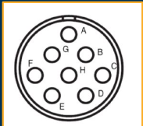
Radio Connections
SNR900/910
- A- SW PWR 1
- B- GND
- E- CAN Hi
- H- CAN Lo

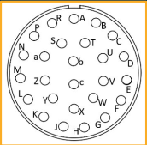
SNR920/930
- A- SW PWR 1
- B- GND
- C- CAN Hi
- D- CAN Lo

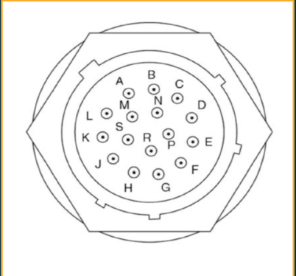
MSS9X – 16 Pin Connector
- A – RS232 GND
- B – GND
- C – CAN1 Lo
- D – CAN1 GND
- E – Chassis GND
- F – RS232 - 1 TXD
- G – PWR
- H – Boot Monitor
- J – RS232 - 1 RXD
- K – CAN0 GND
- L – CAN0 Lo
- M – Instance 1
- N – CAN1 Hi
- P – CAN0 Hi
- R – RS232 - 2 RXD
- S – RS232 - 2 TXD

